# *Maintenance Project (420-E71-HR)*

# *Task 6 – Retrospective – Sprint 2*

Date assigned: Thursday, May 10, 2018

Date due: **Tuesday, May 15, 2018, 23h59**

**Learning Objectives**

Upon successful completion of these tasks, the project team will have:

* Completed a group retrospective for Sprint 2
* Perform a self-evaluation of your performance on the project team
* Completed a peer review for Sprint 2

To do:

# Section A - Group Retrospective And Plan– Prepare

Before participating in the group retrospective, ensure the following tasks are done and complete the checklist.

|  |  |
| --- | --- |
| Task | Completed (Y/N) |
| TFS is updated for “hours remaining” on any of your outstanding tasks. The state of all your assigned tasks are correct. | Y |
| TFS is updated to track all relevant issues | Y |
| Recap the meeting minutes and achieve group consensus that it captures all the decisions and actions. | Y |

# Section B – Self Analysis

Answer each of the following questions by thinking about your contribution to this course so far. Consider only the work you have performed so far in this course.

1. With the introductory work and the first two sprints complete, what has been your greatest contribution to the class overall?

**I worked on the log in API for the system and got it working entirely for Clara and Active Directory users. It should work for local users but remains entirely untested for them.**

1. What area(s) of your work in this class have given you the most satisfaction and why?

**The thing that’s given me the most satisfaction is feeling like I was actually doing something, which was a lot more than I can say for the last sprint.**

1. What area(s) of your work in this class have been dissatisfying and why?

**I know that I still could’ve been doing a lot more. I got the log in API working, but ended up doing more account management stuff that wasn’t supposed to be included when I could’ve been worrying about working on something else. I copied a lot of RAC code to CSAdmin to get this set up and in the end, it wasn’t necessary.**

1. What are your specific strengths and skills when it comes to maintenance?

**I don’t see myself having any particular strengths when it comes to maintenance in particular. I think I’m decent at reading other people’s code and following paths through the code to understand what’s going on, which helps, but I think that’s just a general programming skill, not strictly something that helps with maintenance.**

1. What are your specific weaknesses and areas of improvement when it comes to this course or maintenance in general?

**I think that in this course I had a big issue with lack of motivation, but I feel as though that was something specifically related to this course. I don’t think that I have particular weaknesses in the area of maintenance, but I know I felt less motivated when I wasn’t making something new.**

1. How could you be more helpful to the people on the team (or in the class)?

**I think I could’ve been more helpful by not working on the account management portion of the API and worked on testing the new semester page. It needed testing and I’d misinterpreted what needed to be done and ended up wasting time on it.**

1. Briefly discuss providing feedback to your peers (even though they did not see it). What were the challenges in evaluating your peers? Is it a worthwhile exercise for YOUR development to attempt to provide honest feedback in that manner?

**I had a hard time evaluating them simply because I honestly wasn’t entirely sure what everyone was doing. I was working on an isolated portion of the system on a team of 9 people. I couldn’t keep track of what everyone was working on, so my evaluations were based on “when I looked at their computer, they had VS open.”**

1. If you were a hiring manager right now, given your work in this course ONLY, would you hire the “you” from this course? Why or why not?

**From the whole course, no. I might based on my performance from sprint 2 alone, but I did very little in sprint 1. My biggest mistake in sprint 2 was misunderstanding Allan, which resulted in wasting time, but the work itself I feel was good.**

# Section C - Group Retrospective

### **Sprint 2 retrospective:**

Have a group retrospective and capture the following:

This sprint’s Retrospective:

What went well?

**Overall,**

What didn’t go so well?

**Overall, this sprint didn’t go so well. The system was very buggy, the main deliverable didn’t work, there was many smaller ones broken, and the presentation was overall pretty bad. Allan rejected both systems.**

What have we learnt?

**Focus on the deliverable that is most important to the user. Allan said that the new semester page is what was most important to him and it did not work.**

What is still mysterious?

**There’s not much that’s mysterious to me.**

What bugs us?

**I’m confused about why Allan doesn’t want more than just log in for local users since it would make the system infrastructure easier for local users in the future, but it works, so it’s fine.**

How close were your effort estimates?

**For the most part, my estimates we’re pretty close this sprint. Most of the work this sprint was refactoring and copying code from various parts of other projects and reading it over to understand how it all worked together.**

Capture outcomes: Decisions & Actions:

**In the end, our project did not get accepted. There was far too much not working, and many bugs left in the system.**

Please copy and paste a screen cap of your code coverage:

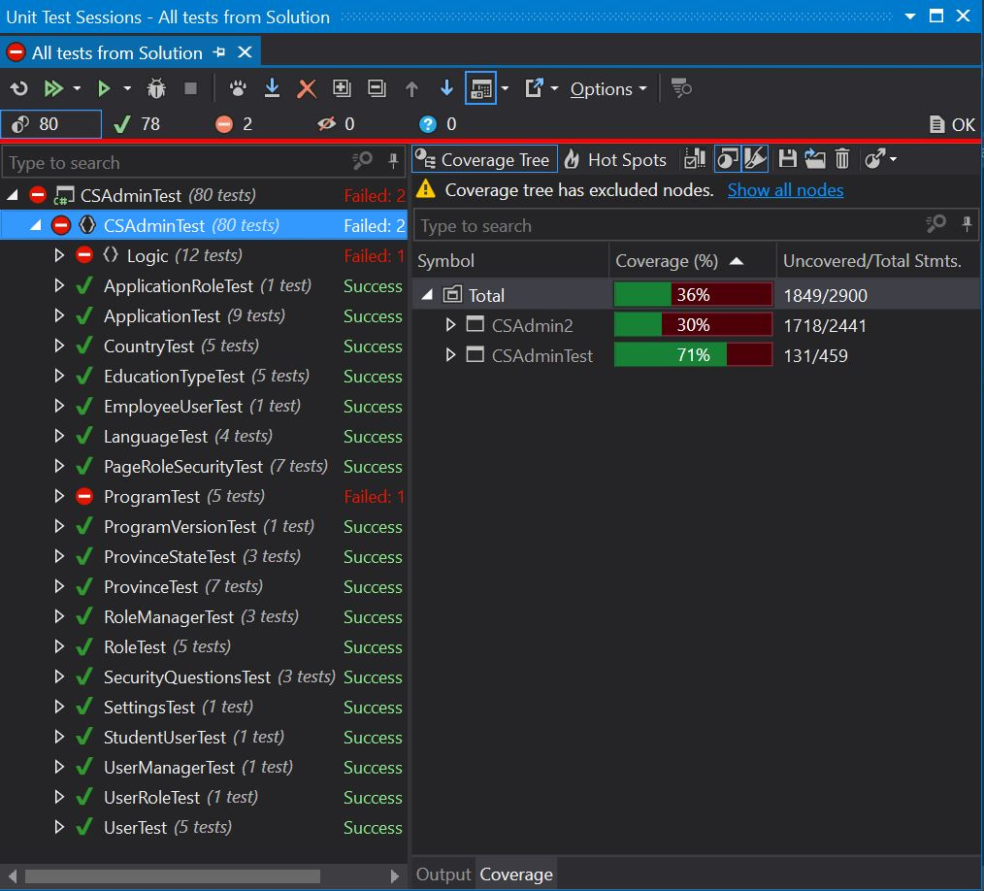

# Section D - Peer Review

See Teammates invitation for the peer review.

Make sure you provide constructive criticism to the other members. Note: AND THIS IS IMPORTANT. This is an exercise in how you provide feedback. The marks you allot will not only factor into the other person(s)’ mark, but will factor into your mark. So make sure you provide honest, direct and constructive feedback as YOU are being evaluated on your ability to provide feedback. This will account for 2% of your final mark.

Yes, you have to know what your team mates are working on daily. It’s why we have those daily scrums.

You **MUST provide comments** for any mark that is a 1 (Unsatisfactory) or 4 (Exceptional). List specific examples if you can.

# Section E – Deployment Guidebook

* Please submit your Deployment guide as part of this assignment, it must be a formal document which must be completed in full sentences with sections and headers.
* You may want to follow the step by step approach, and may want to use screen caps to help the user follow your deployment guide.

**To submit**

Submit to Moodle